**The Ark Documentation.**

**Manager Users module.**

Log in and select your study by clicking the hyperlink corresponding to the name of your study.

Once you have chosen your study we will be able to adjust study details or select modules and functions available in that study (for which you have privileges).

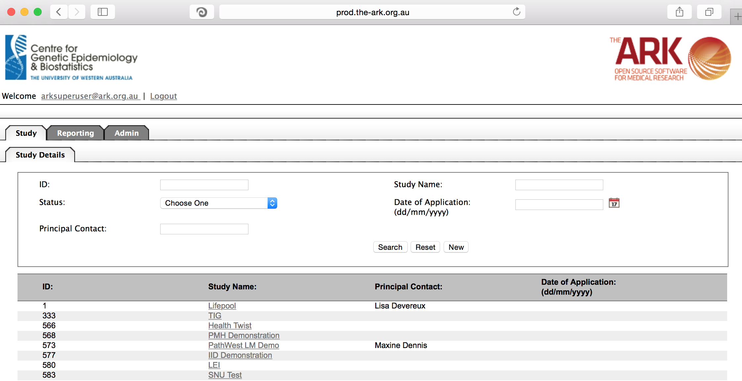

Alternatively if you have a very long list of studies under your management you may use the search pallette/panel at the top of the page. You can search/filter by id, name, principal contact, status of the study or date of application. Once you have added your filtering criteria, click the search button;

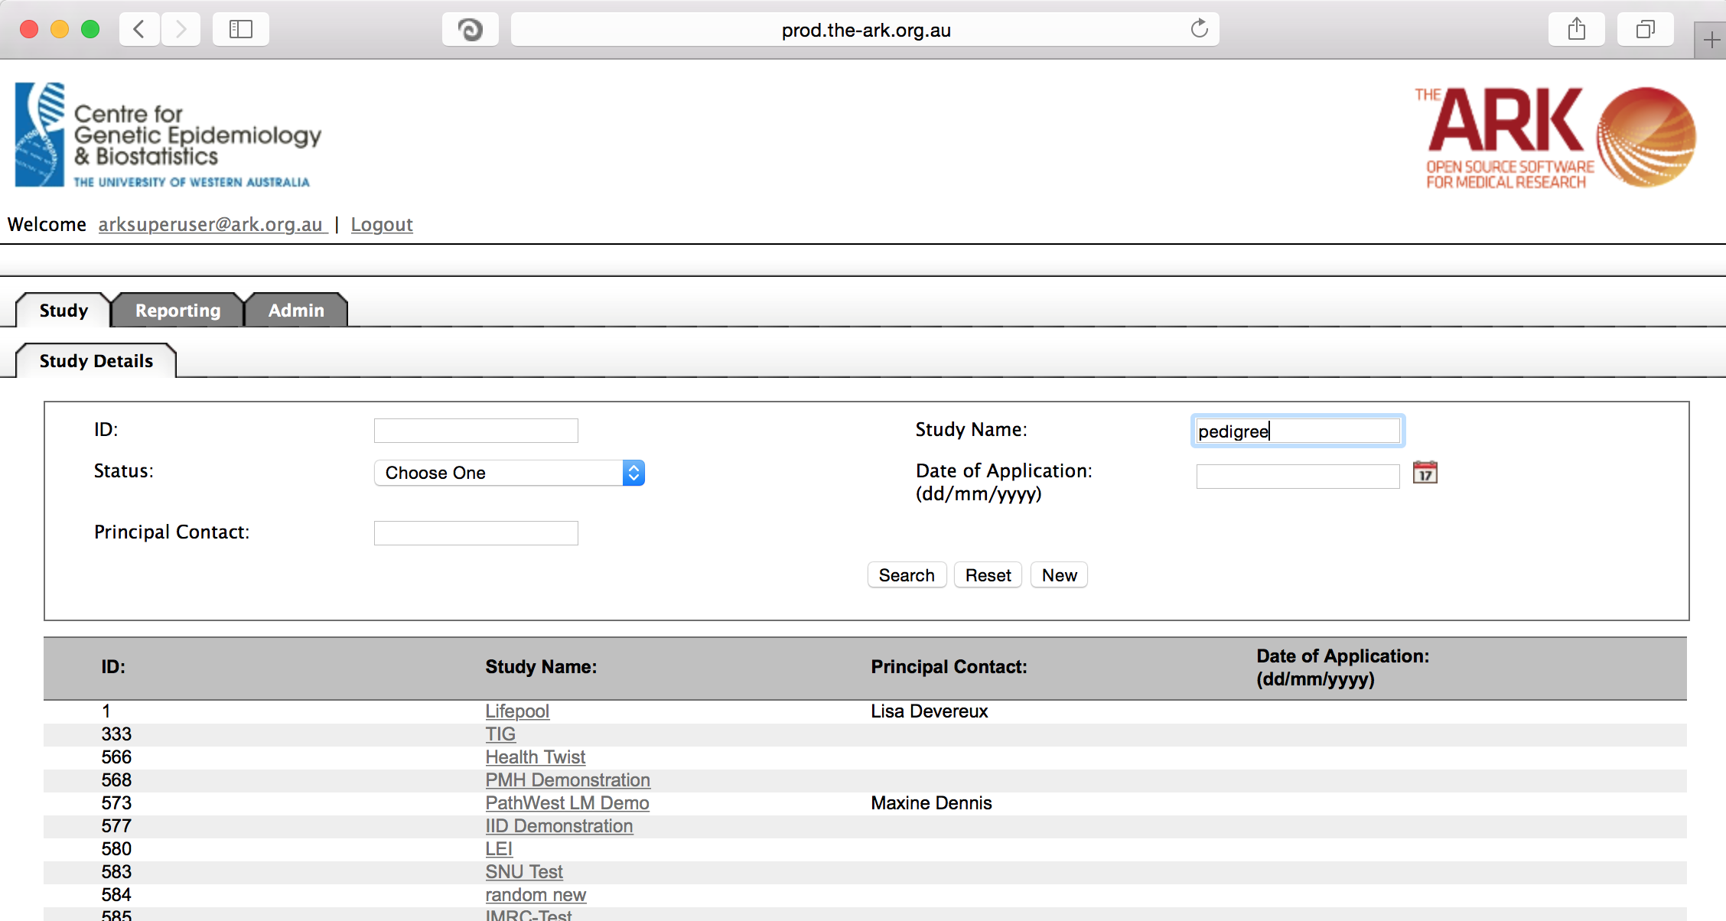

As you can see the filter has helped us find our chosen study and we can click the hyperlinked study name as discussed before;

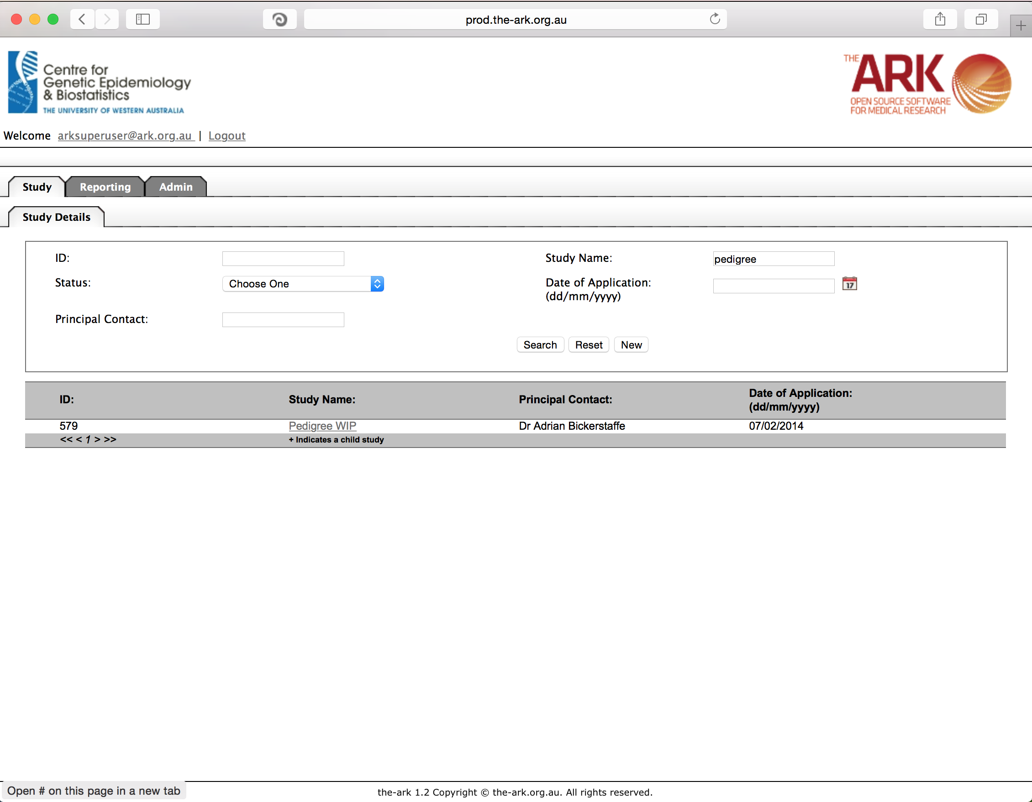

Once you have chosen your study we will be able to adjust study details or select modules and functions available in that study (for which you have privileges). The module we wish to select is Manager Users.

This is where we are able to control users’ access to our study in context (in the case of this picture you can see the study “Pedigree WIP” is in context). As with all pages, our list will be displayed below, and we can search/filter/refine that list with and of the fields by clicking the search button.

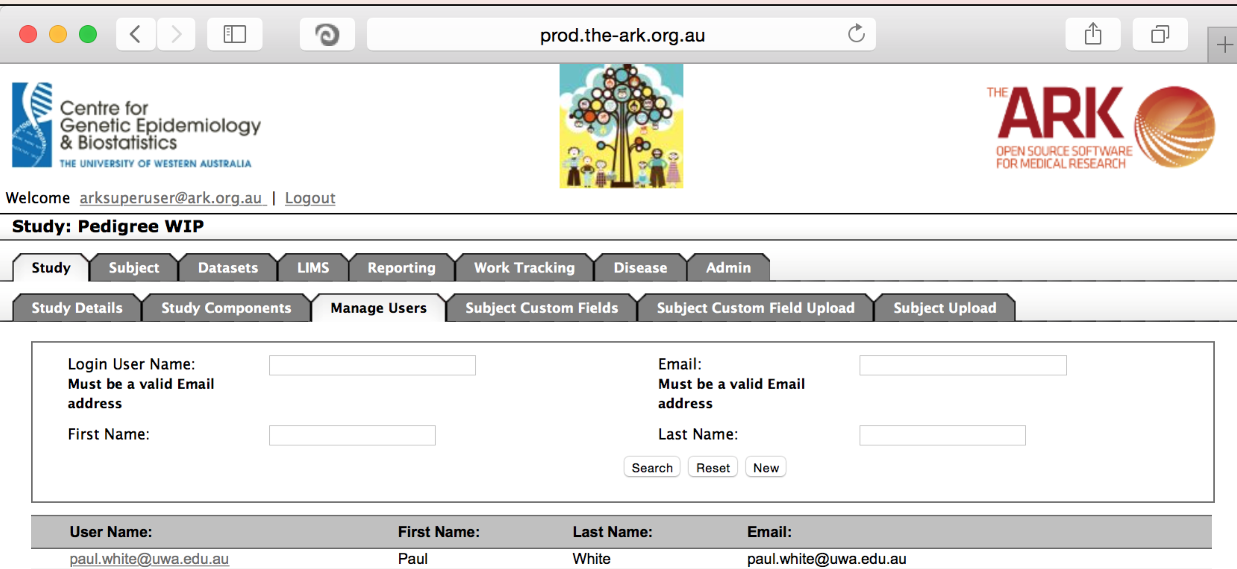

We will start by creating a new user.

Start by clicking the new button. The following will appear;

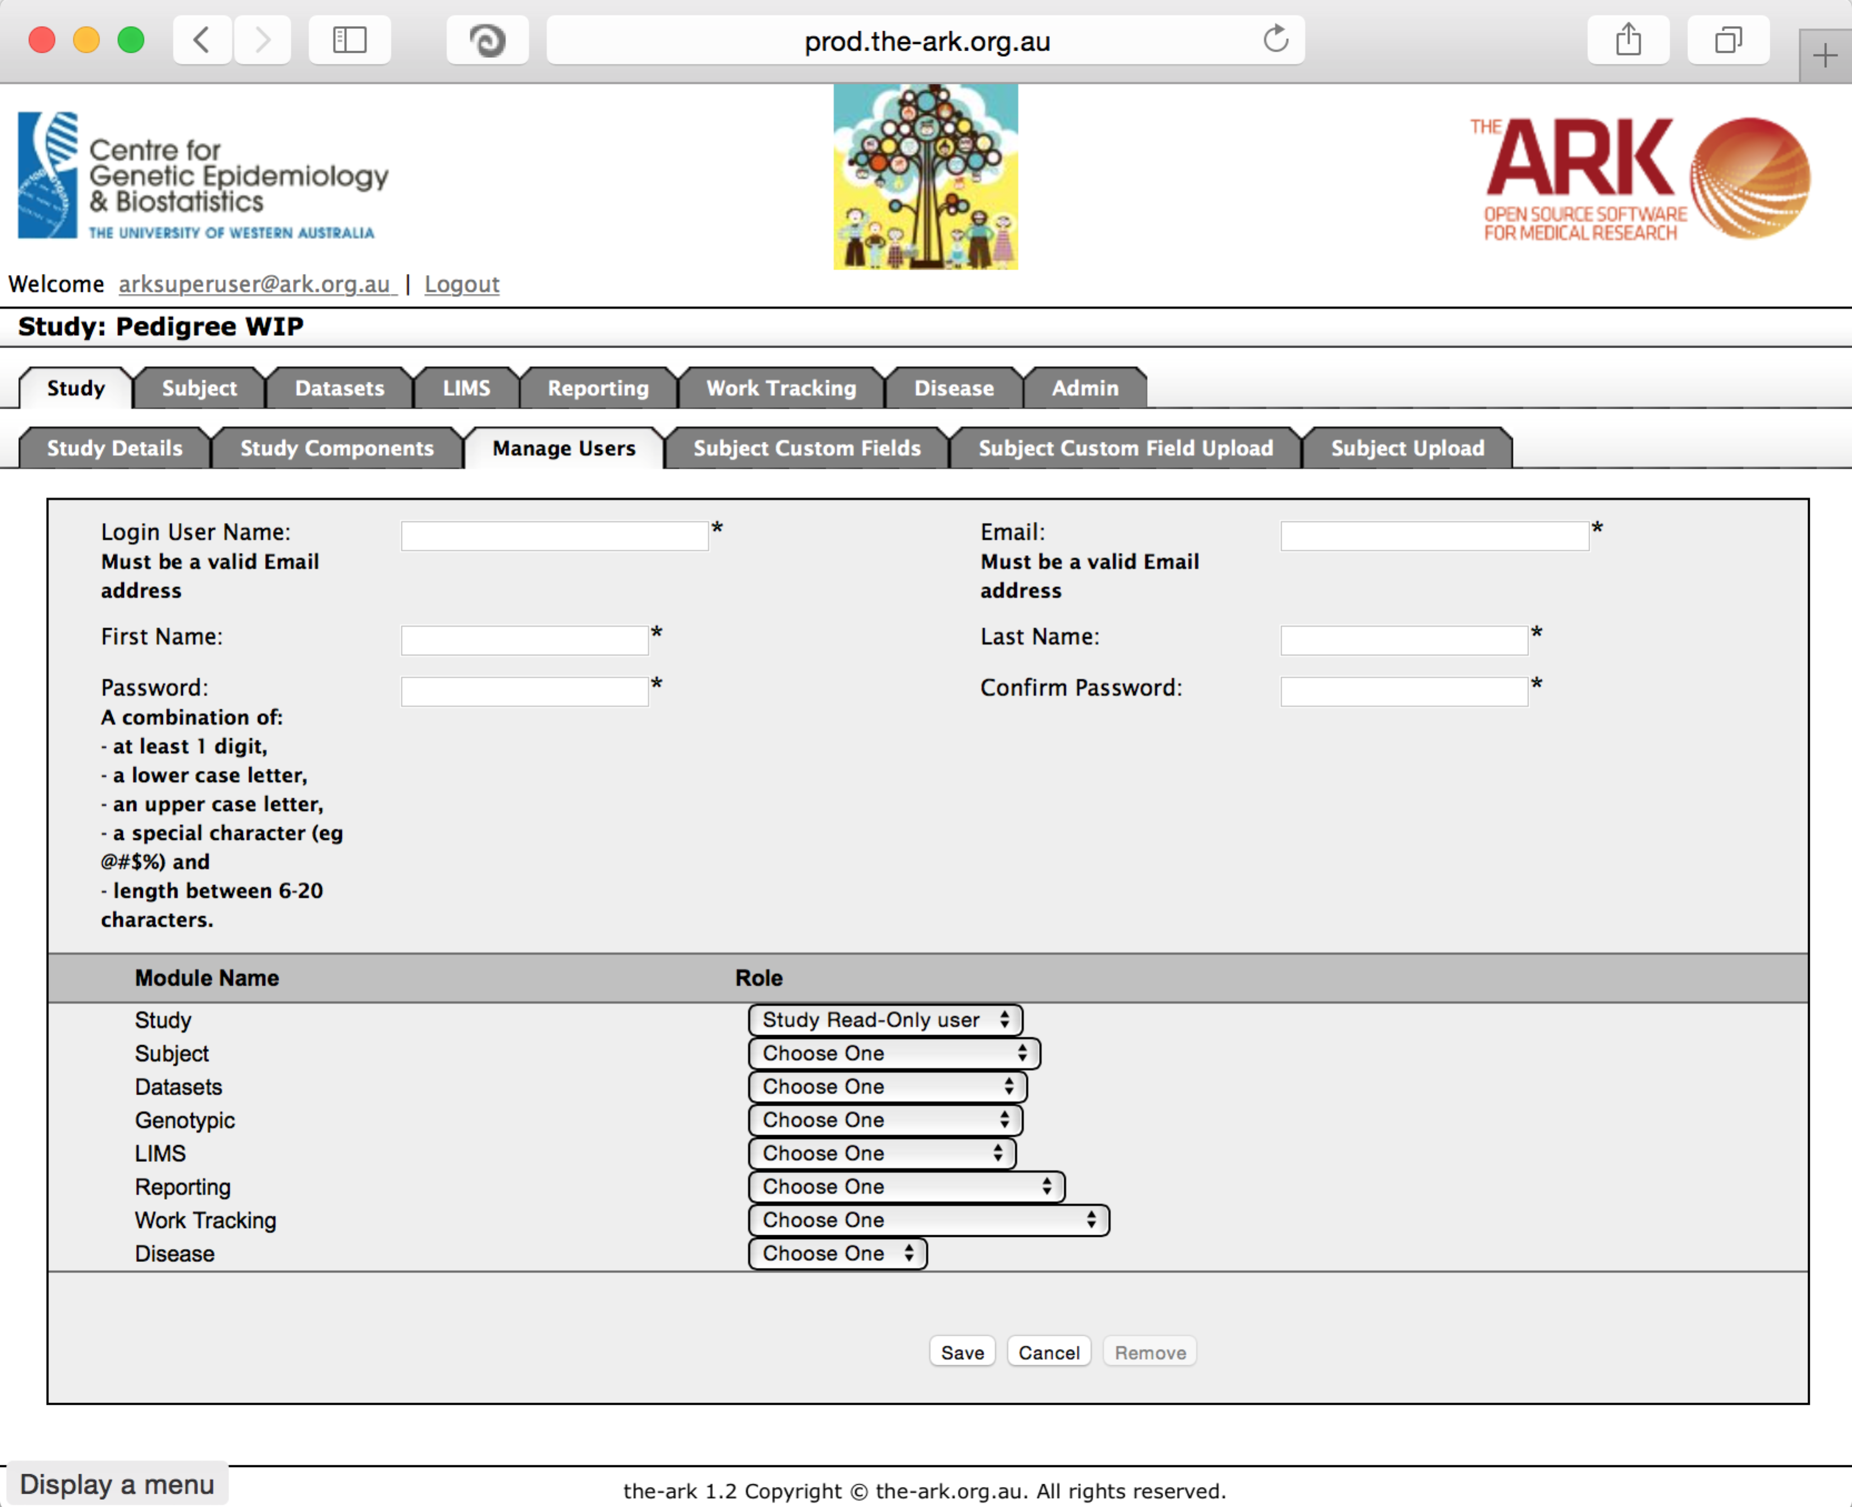The fields are all self-explanatory and will be searchable, except for passwords and permissions (though a report is available of all permissions for a study – see reports documentation).

You will notice there is a role for every module. You can be an administrator (control what is available to the study and alter it), data manager (read or write data but not manage what fields are in the study) or read only access for that module.

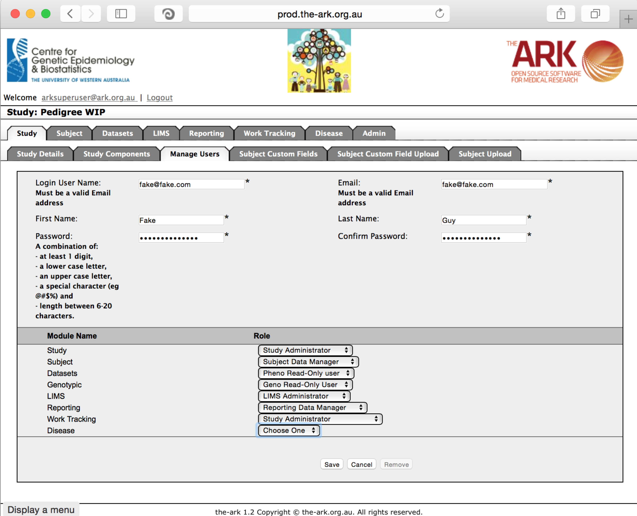

Then click save;

If you have no issues and it has correctly saved, the you will have a green message at the top of the page telling you so. If there were any issues (I have included an appendix for common errors at the end of this document), a message will show up in red describing what you have done wrong.

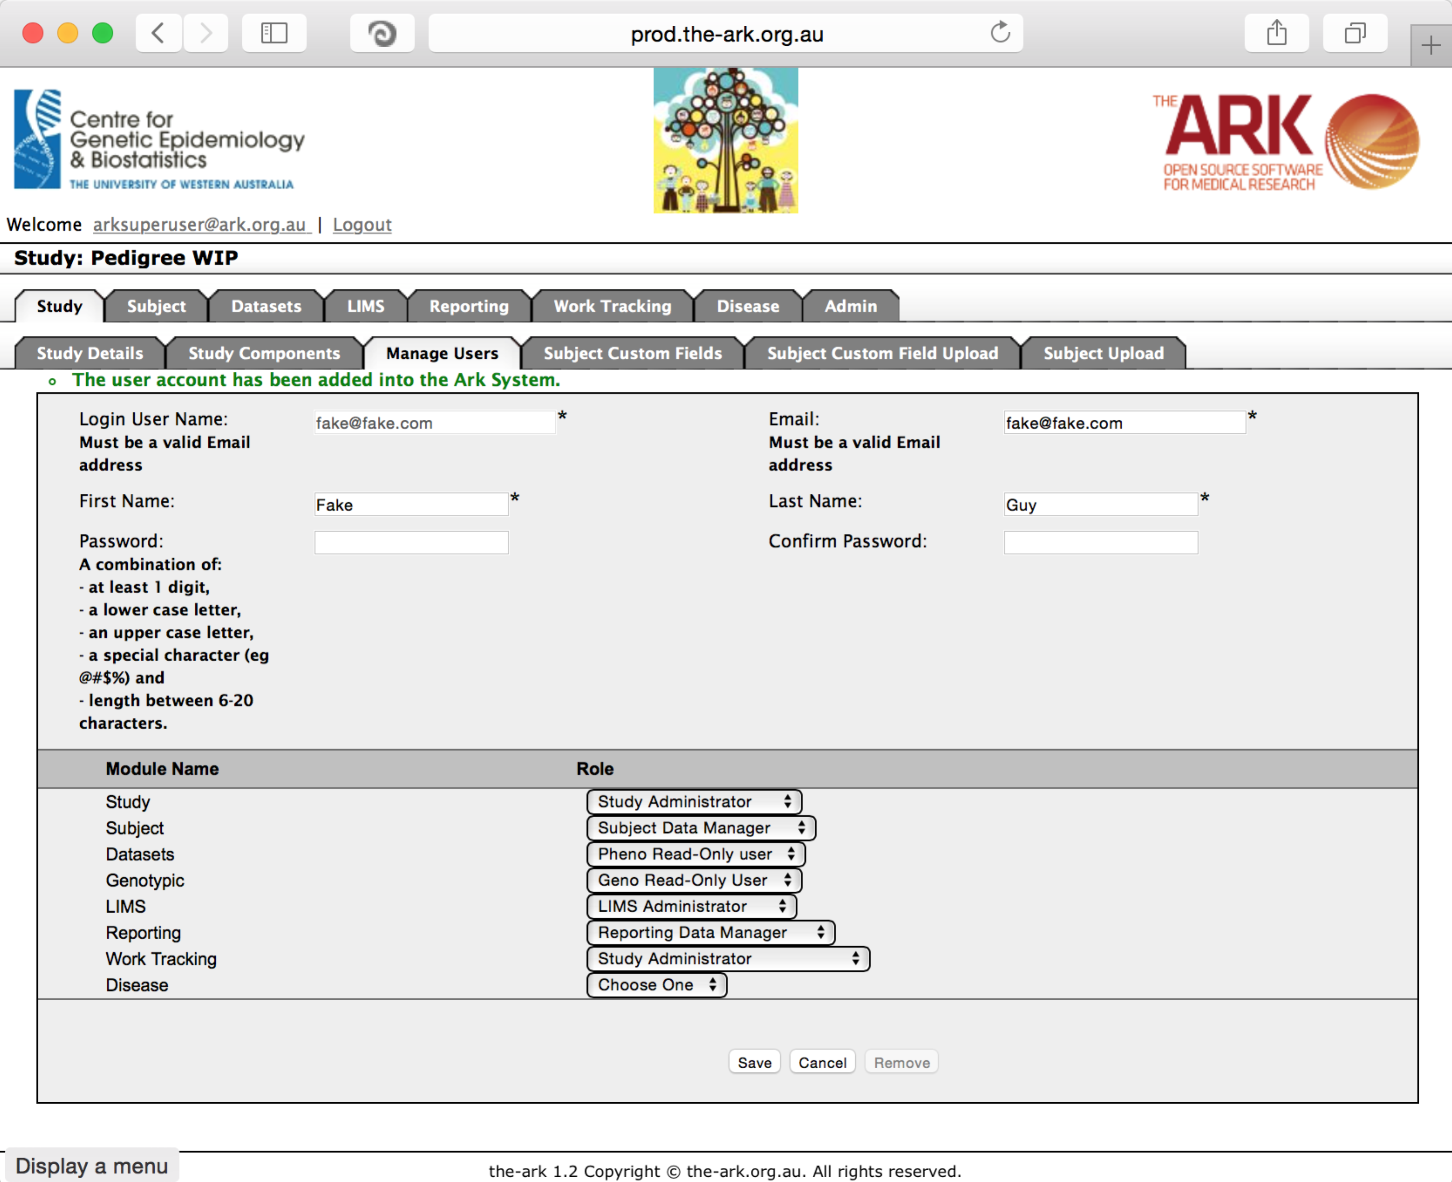Common errors;

Passwords must match. We also recommend keeping username and email the same to keep consistency and make it easier to manage your users.

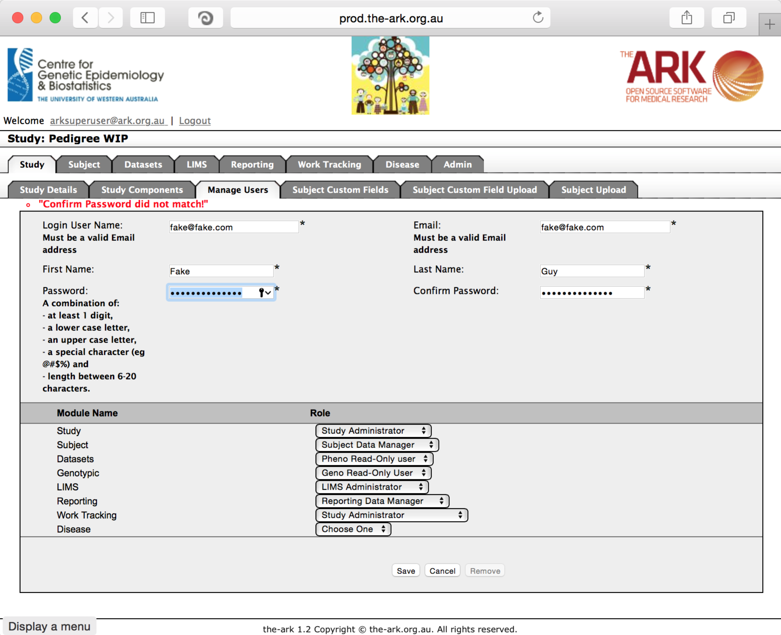Another common problem is that the password may not match the required complexity

There error message is fairly self-explanatory, but to expand it out a little;

“**Password should contain;**

**at least 1 digit,**

**at least 1 lower case letter,**

**at least 1 upper case letter,**

**at least 1 a special character (eg @#$%)**

**and the length of the password be between 6-20 characters.”**

